AURANGZEB PUSH MS 1 & 2 TO GIT

Project Features/Requirements List: Frontend and Backend

* Title: [Nav bar](https://www.w3schools.com/howto/howto_css_navbar_icon.asp) with dropdown menus
  + Description: This feature will have options for things such as: Homepage button, Login/Register button, User Account button, Search tool, etc.
    - Requirements:
      * Functional:
        + Navigation bar displayed on the left side of the screen
        + Different buttons will be dropdown-like. Pops out to the right of the navigation bar
        + Navigation bar contains different options for user to interact with (Go to homepage, Login/Register, etc.)
      * Non-Functional:
        + Navigation bar must be easy to read/follow for user (smooth UI)
* Title: [Search tool](https://www.w3schools.com/howto/howto_css_animated_search.asp)
  + Description: Search recipes and tutorials by difficulty of preparation, nationality, dietary restrictions, appliance requirements, and duration.
  + Have both a search bar and an advanced search page.
    - Requirements:
      * Functional:
        + Narrow search criteria based on user input
        + Search bar has two functions

General search is a quick search that matches based on words

Advanced search restricts search results to criteria based on user preference (filter options)

* + - * Non-Functional:
        + Give the user an option to quickly search for a recipe/food, and also give the user an option to limit search results
* Title: User Account
  + Description: Register or [Log in](https://www.w3schools.com/howto/howto_css_login_form.asp) to an account based on email and save favorites, keep your place. Ability to bookmark favorite recipes
    - Requirements:
      * Functional:
        + Click Login, be prompted with a forum to put login info into.

Database stuff

* + - * + Register button, prompts to put in username, email, and password information

Database stuff

* + - * + Favorites tab. Holds different recipes that have been favorited/saved on that account

Database stuff

* + - * Non-Functional:
        + Provide the user with a way to keep track of favorite recipes and provide general account info.
* Title: Quick start option
  + Description: Invoke a forum page asking for what ingredients you have in your kitchen, what utensils you currently own, what dietary restrictions you have, etc, and then return a list of recipes that the user can choose from, which can be further filtered down by either a time restriction or difficulty level.
    - Requirements:
      * Functional:
        + Individual page accessed from nav bar.
        + Enter a list of ingredients in your fridge/cupboard/pantry and receive a list of recipes that can be made using those.
      * Non-Functional:

•Should be relatively quick to enter (perhaps using autocomplete for basic ingredients)

•Search should resolve quickly

* Title: Comments/Reviews
  + Description: If logged into a user account, can add reviews of recipes with star rating as well as a text. Will be loaded and displayed below each recipe.
    - Requirements:
      * Functional:
        + Allow a user logged into an account to leave a review/rating for a recipe
        + Allow a user not logged into an account to view reviews/ratings
        + Display various reviews (text) below the recipe. Display a star rating (number) above the recipe.
      * Non-Functional:
        + Provide the user with a way to give feedback on how the recipe worked for them
        + Provide the user with extra knowledge on that recipe
* Title: Video Tutorials
  + Description: Before each recipe, embed a video tutorial displaying how to utilize the recipe. Tutorials will be sourced from sites such as Youtube and other cooking videos.
    - Requirements:
      * Functional:
        + Embed the video tutorial above the recipe
        + When the user clicks play, the video plays while the user remains on the recipe page
      * Non-Functional:
        + Provide the user with extra information/details on how to utilize the recipe provided to them

Project Plan:

Using asana.com

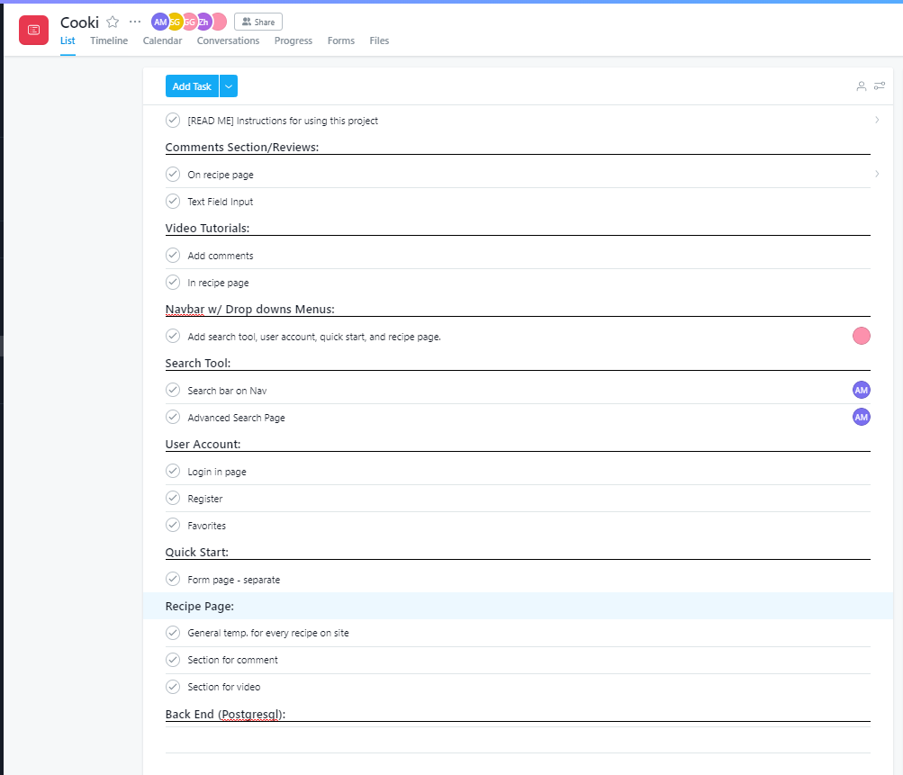

Board meeting:

